My mini-textbook for Imperialism in Canada
Pre-History
This is the period of time before traditional "history" is available. Rather than writing things down, the aboriginal peoples used stories, legends, songs, carvings (like totem poles), and dances to pass knowledge from one generation to the next. This form of knowledge has often been criticized as being flimsy, loose, or inaccurate. But it has been gaining respect recently. Archeological digs have also helped to verify much of the information, and to uncover some that was lost.
Once Europeans started showing up, they immediately began recording history. This is biased information, but it does help us gain understanding of events. Along with recording history, the Europeans' arrival also started a significant time of change for the aboriginal peoples. Their lives would never be the same.
Aboriginal peoples lived in "bands." These were just like the tribes in Africa. They had chiefs, their own languages, they had regions of land which they considered to be their own, traded with each other, and they sometimes fought each other over land, resources, etc. Aboriginal peoples were organized, with distinct cultures for each society that was heavily influenced by the physical environment they lived in. The Iroquois Confederacy was a group of FIFTY chiefs who formed an alliance to protect and provide for their people.
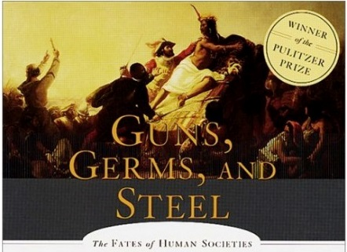
The bands were not as far along as Europeans in terms of science and technology. There are several reasons for this. A very famous book called "Guns, Germs, and Steel" was written about why aboriginal peoples were a little behind in these areas. Some bands suffered big time when the Europeans showed up. The Beothuk people were completely killed off! They are extinct and we barely know anything about them. Diseases like smallpox and tuberculosis were devastating. Guns and alcohol were new to aboriginal peoples, and they struggled to use them responsibly at times. In total, estimates are usually around 50% of the natives being killed or dying because of colonizers. The idea of personally owning land and working for yourself rather than the tribe was also a completely new mindset – a much more selfish one.
Pre-history is considered to be closing when the Vikings showed up around the year 1000, and it ends when the Europeans arrive in bigger groups around the 1490s.
2 Worlds Meet
Europeans landed on the east coast. This is why the Maritimes has Canada's oldest cities. Some Europeans came as colonizers, settlers, soldiers, farmers, and a few government officials. The arrival of Europeans begins a trend that would not stop: the aboriginal peoples would be pushed back, pushed away, and pushed down to make room for Europeans.
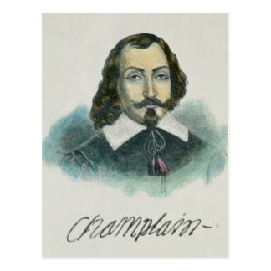
Those French People
Famous explorers like Cartier and Champlain kicked things off with first French settlements being built along the St. Lawrence River. France was in serious competition with other European countries like Britain and Germany to scoop up new territory to make money off of – IMPERIALISM!
It wasn’t an easy go of it for the early French settlers. Many of them died from sicknesses that their immune systems weren’t prepared for. But eventually a few major developments were built and populated. Quebec City and Montreal are examples of this. Champlain is a legend, and his nickname is "the Father of New France." They called it New France because it was the new world, and because it was now France's territory. That's right; they pushed the natives away and gave the place its own white name.
The building of New France has two major phases: First, the French government sent companies of explorers to settle the area and to make money. This was big business! But these people had zero interest in actually living here or making a long term commitment. The second phase started around 1663 when France's rulers began encouraging and paying settlers to move here to establish permanent settlements and businesses.

Here Come the English!
England originally sailed this way looking for a shortcut to China. They wanted to sell their goods there. Once they realized there was a continent in the way, they decided they would set up shop there. Most of England's settlers were sent to the land that is now the USA. These are called the "original 13 colonies."
England did set up a few small operations in Canada. Fishing stations were built in Newfoundland. This annoyed France, because they were claiming the Canadian area already.
The competition between England and France really heated up when the fur trade started rocking. Eventually, they would have a serious conflict over business in the new world, and everywhere else too really.
The 7 Years War was the first war that happened all over the world! France had worked hard to build up some partners and take on Britain (who was buddies with the Russians, sort of). They fought in Europe, the Mediterranean, all over the world's oceans, and right here in North America. The winner would get even more world power, and control over the area known as New France (Canada), along with all its resources to make money off of. Having a strong Navy was incredibly important for this war. You needed to sail all over the place, send troops and supplies, and control the shipping of resources and materials. Britain realized this early on, and spent a ton of money and workers on building the greatest Navy in the world. It worked. Britain won. This is when Canada shifted from being governed by France to being governed by Britain. All those French settlers felt very abandoned and angry that their mother country had let this happen. This is partly why Quebecers still talk about separating nowadays, and have their own way of doing things (like their legal system).
England Sets Up
Now that they had control, the English went to work establishing things their own way so that they could make that green! Over the next while, England would set up government, taxes, and military in the new world. In Canada, it went ok. In America, it definitely didn’t. We will learn about the American Revolution later in the year. For now, keep thinking about imperialism in Canada.
England had a few goals early on. They wanted the French people to adopt the English way of life. They wanted to make major cash by exploring the wilderness and aboriginal peoples' territory. And they wanted to get all the separate colonies in Canada on the same page.
Some famous explorers like Mackenzie, Fraser, and Cook lived during this time. They were brave and bold men who mapped much of Canada and set up new developments.
The fur trade seriously took off around now too. Two main companies, the Hudson Bay Company and the Norwest Company entered into major competition with each other.
Upper and Lower is Upside-Down!
New France was renamed British North America. England's main two colonies were Upper Canada and Lower Canada. You need to understand what this means. It's about the St. Lawrence River. The people living in these colonies got very upset with the way the British were doing things, so they had a little rebellion going on. Eventually Britain agreed to make some changes.
The White Man's Burden
European governments pressured colonizers to "civilize the savages." Well, that says a lot right there. The aboriginal peoples were civilized. They had plenty of organization and were working hard to have happy lives. Calling them savages, Indians (um, not in India), and other names we consider racist nowadays was totally normal back then. Europeans viewed themselves as being at the top of the Social Darwinism ladder. They considered it their responsibility to "help" others catch up by assimilating them into European life. They wouldn't do this for free. They would trade their knowledge and lifestyle for land and resources, whether you asked for it or not.
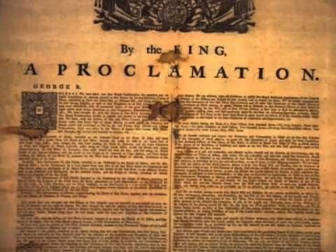
The Treaties & Reserves
At the end of the Seven Years War (1763), King George III of Britain (now controlling Canada) issued the Royal Proclamation. THIS IS A BIG DEAL. The Royal Proclamation ordered how the aboriginal peoples were to be treated. The document stated that lands being lived on by aboriginal peoples was owned by aboriginal peoples, and that the surrounding lands was hunting territory. It also explained how the settlers could purchase or trade for land, and how agreements should be done. This deal doesn't sound so bad. BUT, the British are passing legislation over the aboriginals. What business do they have acting like they have authority over them?! The aboriginal nations were no longer considered independent and self-governing; now they are simply groups living under the British rule. Imagine being an aboriginal person at this time! Your whole life is changing. It's like moving to a new foreign country but you didn’t actually go anywhere.
British government officials began negotiating treaties and trades that totally ripped off the aboriginal people. Large portions of prime land were gained by settlers, and the aboriginals moved into "reserves" where they got hunting and fishing privileges.
The Indian Acts
When Confederation happened in 1867, it was called "the British North America Act." It was a legal document that put "Indians and Indian lands" under Canadian government authority. Slowly but surely, the Canadian government passes "Indian Acts" that took more control over aboriginal peoples' lives. Eventually, aboriginal peoples had to get permission to sell their crops and to wear their traditional wardrobes off of the reserve. Natives were banned from drinking alcohol (after the British had been giving them tons of it), and from gambling. They were encouraged to snitch on each other and were paid for doing it! Aboriginals were not even allowed to vote yet, so they had no say in who was controlling them. They also were not allowed to be lawyers or on a jury in court because they weren’t considered educated, smart, or trustworthy.
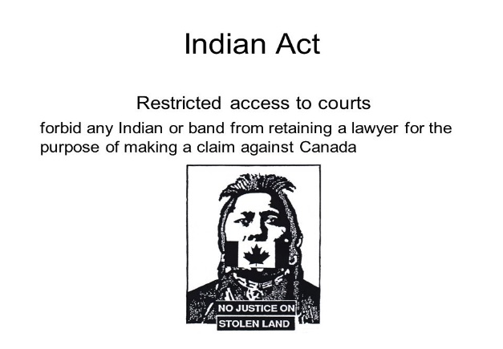
Canadian government went even further. The traditional ceremonies of Potlatch (west coast tribes) and the Sun Dance (prairie tribes) were labelled as "for barbarians" and outlawed. This would be like our government making Christmas illegal! Potlatch was a time of gift-giving and Europeans considered this counter-productive to teaching aboriginals about property and ownership.
In 1885, General Middleton introduced the "Pass System" which meant that aboriginals could not leave the reserve without getting a pass from the whites. This was not even legal under the Royal Proclamation or Indian Act, but the whites did it anyways and it lasted until the 1930s.
Even the lands that were being protected as reserves were eventually exploited. Settlers came in for mining and forestry. When aboriginals began taking their complaints to court, the government passed a law that made it illegal for aboriginals to have a lawyer! WOW. So racist. So unfair.

Not even a "person"
Until 1951, the Canadian government defined a "person" as "any individual who is not an Indian." Can you even believe that?!
Aboriginal people were called "wards of the state." (Ward is another word for "property" and state is another word for "government.") If an aboriginal wanted to legally be a "person" and have the right to vote, have a lawyer, go to school, etc., then they had to give up their aboriginal status – including the way they dress, their traditions, their whole culture. Not very many of them chose to do this, so the government started doing it to people without them asking for it! Duncan Campbell Scott was the Superintendent of Indian Affairs (the government boss of all things to do with aboriginals). He said at the time:
"Our goal is to continue until there is not a single Indian in Canada that has not been absorbed, and there is no question and no Indian Department."
Aboriginal women were treated especially poorly. Great, our government was racist AND sexist. Any aboriginal woman who married a white man would no longer have aboriginal status, and her kids wouldn’t get it either. Aboriginal tradition placed great importance on the mother (rather than white way of focusing on the father), so this was pretty darn bad.
The Worst Part - Residential Schools
If the government really wanted to teach the aboriginals how to live like the whites, then they needed to educate them. Around the middle of the 19th century (1840s), the government of Canada created "industrial schools" that aboriginal kids would live at and "learn how to be civilized and Christian." THEY WERE TERRIBLE PLACES. The schools in Canada got their design and structure from the Carlisle Indian School in Pennsylvania, USA. Carlisle's school motto was "Kill the Indian in him and save the man." By removing aboriginal kids from their families and homes, the government hoped to kill the Indian in them, and therefore future native children would not learn the culture of their ancestors.
The Indian Act of 1876 made aboriginal children the government's responsibility, instead of their parents. By 1910, residential schools were the main policy for native education. Many churches ran the schools. In 1920, attendance to a residential school became mandatory for aboriginal kids. There were 74 schools across Canada. The schools were ordered to give a "dumbed down" version of the curriculum, "because we don't want the native kids being too smart when they return to reserves."
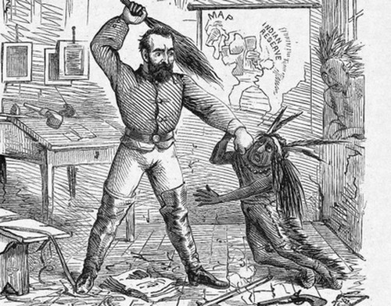
Residential school life was incredibly tragic for aboriginal kids. They schools often didn’t have enough funding, so the leaders forced the students to do manual labor. The student housing facilities had very little heating in the winter, and were over-crowded with several in each bed. The food was awful and there wasn’t much of it. One report from the prairies in 1907 said that 24% of residential school students had died!
Physical, mental, emotional, and sexual abuse was common in these horrible places. Students were punished to the point of death at times. If they were caught speaking their native language, students had pins pierced into their tongues. When they got the flu, principals made the kids eat their own vomit.
Most of these schools were closed during the 1970s (when your parents were growing up). During the 1980s, natives sued the government for the harm they had done to them and their culture. During the 1990s, churches and politicians began to make public apologies. But it took until 1998 for the Canadian government to issue a "Statement of Reconciliation" to the aboriginal peoples. The government also gave $350 million to support healing and recovery of residential school survivors.
Many historians believe that residential schools were the worst thing ever done to the aboriginals of Canada. And they called it the White Man's Burden – almost unbelievable.

Where are we now?
Canada has become known for being a place of peace, with lots of cultural differences, ethnicities, races, and religions. You might have learned in elementary school about Canada being a "salad bowl" where all kinds are welcome and mixed together. But look at our history! Are we really that good?
Today, aboriginals continue to live in conditions that are not nearly as good as non-aboriginals. Aboriginals' life expectancy is shorter than other races here. They have higher rates of unemployment, nearly twice as many infant deaths, and spend much more time in jail than the averages of others. Aboriginals get paid less for their work – they are the poorest people group in Canada.
How did this happen? Imperialism, that's how!

